**IT2020 – Software Engineering**

**Year 2, Semester II, 2022**

**Group Assignment**

**Online Computer Spare Parts Management System**

**Group Details**

**Batch:**

**SE/OOP Group Number: SE/OOP_MLB_WD_2022_S2_129**

|  |  |  |
| --- | --- | --- |
|  | **Student Registration Number** | **Student Name** |
| **1** | **IT21189944** | **Madusanka G.K.I** |
| **2** | **IT21176456** | **Gimmana M.R.M** |
| **3** | **IT21177996** | **Cooray N.T.L** |
| **4** | **IT21174780** | **D.M.M.I.T.Dissanayaka** |

Use Case Diagram

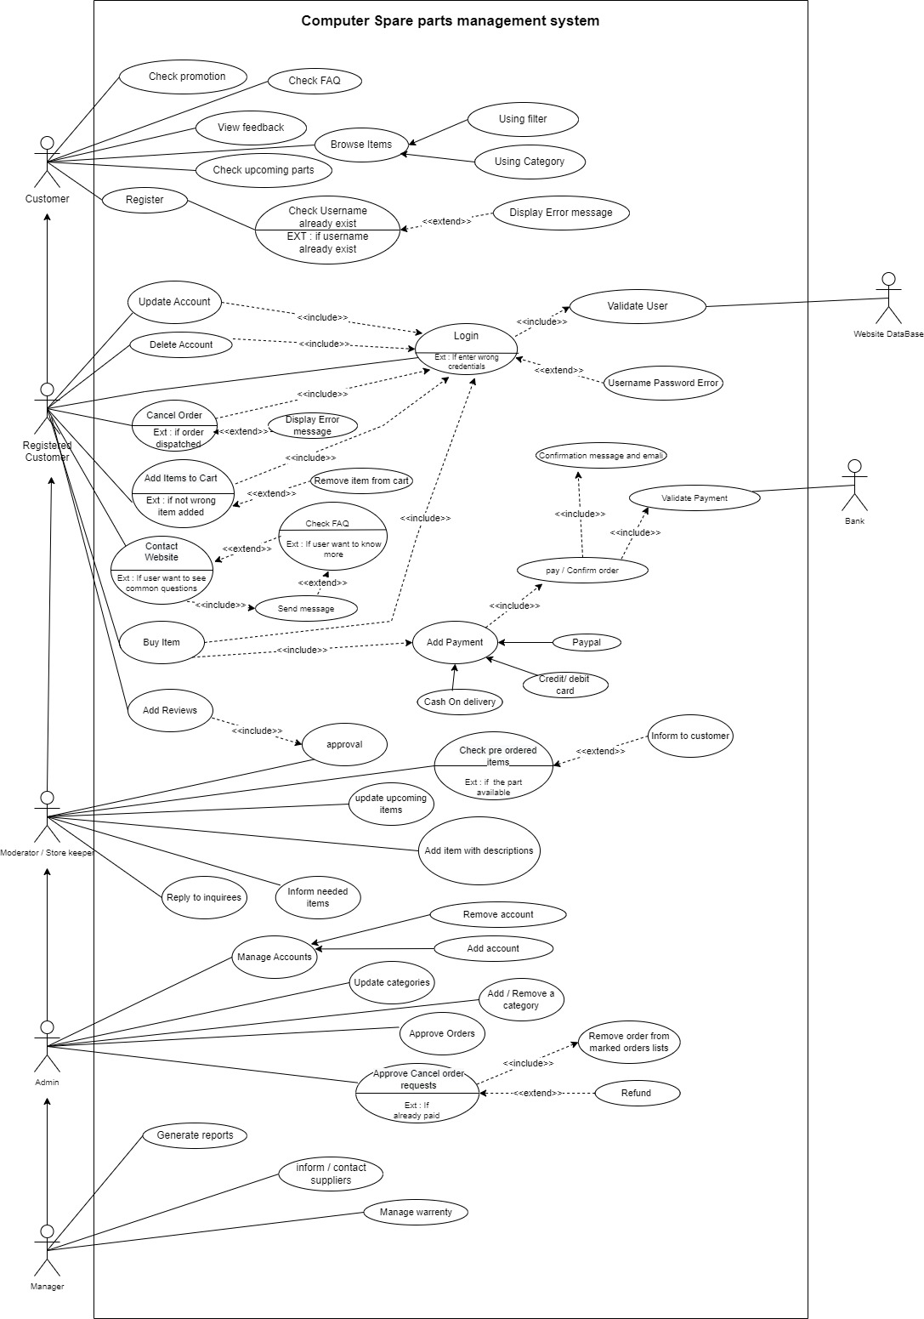

**IT21189944 – Madusanka G.K.I**

* **Customer Registration**

1 . Use case scenario :

|  |  |  |
| --- | --- | --- |
| **Number** | 01 | |
| **Name** | Register | |
| **Summary** | Register as user | |
| **Priority** | 01 | |
| **Pre - Condition** | Guests must visit the website. | |
| **Post-Condition** | The system sends an email of gratitude to the user with a note to confirm successful registration. | |
| **Primary Actor** | Guest | |
| **Trigger** | The guest chooses to register. | |
| **Main Scenario** | **Step** | **Action** |
|  | 1. | Visit the website. |
| 2. | Guest clicks on sign up button |
| 3. | The system displays the registration form and asks to enter the name. |
| 4. | The guest enters the username, full name, email, and password with the mentioned characters and retypes the password. |
| 5. | Guest clicks on the sign-up button to submit the registration form. |
| 6. | The system stores the guest details and sends an email with a PIN to confirm entered email. |
| 7. | Guest entrees PIN on the website |
| 8. | The system sends an email of gratitude to the user with a note to confirm successful registration. |
| **Extensions** | **Step** | **Branching Actions** |
|  | 5a | The system notifies the guest that the entered username already exists. |
| 5b | The system notifies the guest that the entered email is not valid. |
| 5d | The system notifies the guest that the re-entered password is not matched the previous password. |
| 5e | The system notifies guests that the information provided is incomplete. |

2. Sequence Diagram :

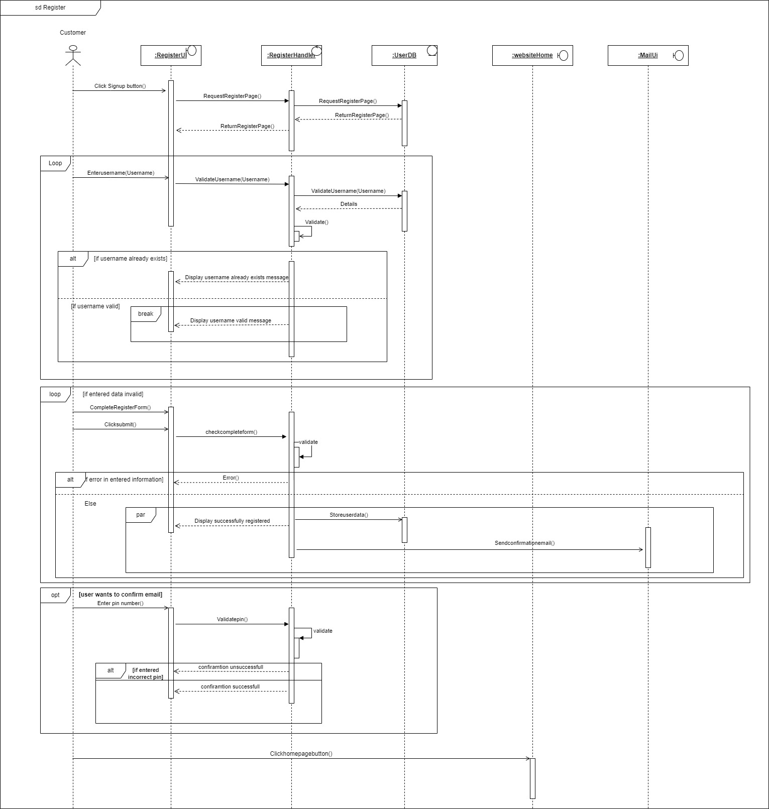

3. Communication Diagram :

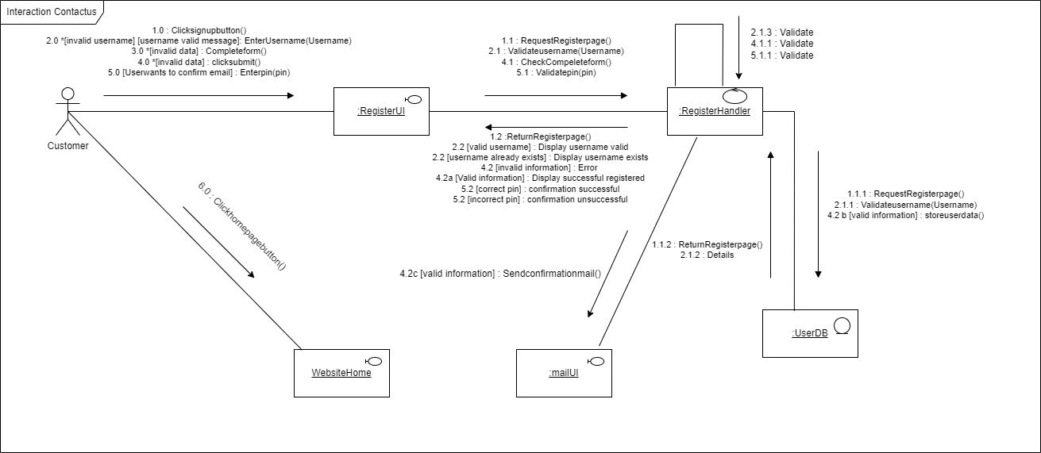

* **Registered Customer contact support services**

1. Use case Scenario :

|  |  |  |
| --- | --- | --- |
| **Number** | 02 | |
| **Name** | Contact us | |
| **Summary** | Customer Inquiry | |
| **Priority** | 01 | |
| **Pre - Condition** | Registered to the system | |
| **Post-Condition** | The customer submits the Inquiry. | |
| **Primary Actor** | Registered Customer | |
| **Trigger** | Registered Customer chooses to contact the website. | |
| **Main Scenario** | **Step** | **Action** |
|  | 1. | Visit the website. |
| 2. | The Customer logins by entering their username and password |
| 3. | Customer clicks on the contact us button |
| 4. | The system displays the contact us page. |
| 5. | Users fill out the contact us form with the necessary details. |
| 6. | The user clicks the submit button. |
|  | 7. | System store the inquiry details |
| **Extensions** | **Step** | **Branching Actions** |
|  | 2a | The system notifies the guest that the entered email or username is incorrect. |
| 2b | The system notifies the guest that the entered password is incorrect. |
| 6a | The system notifies guests that the information provided is incomplete. |

1. Sequence Diagram :

Login –

Contact Support–

1. Communication Diagram :

Login –

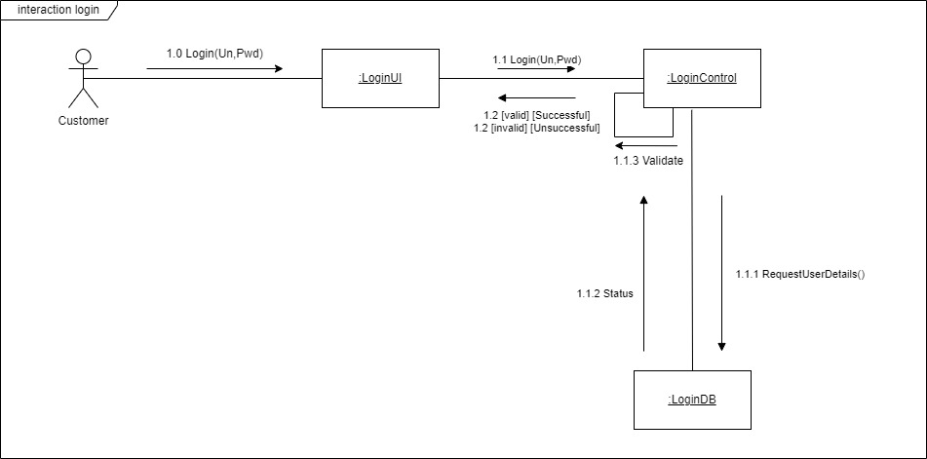

Contactus –

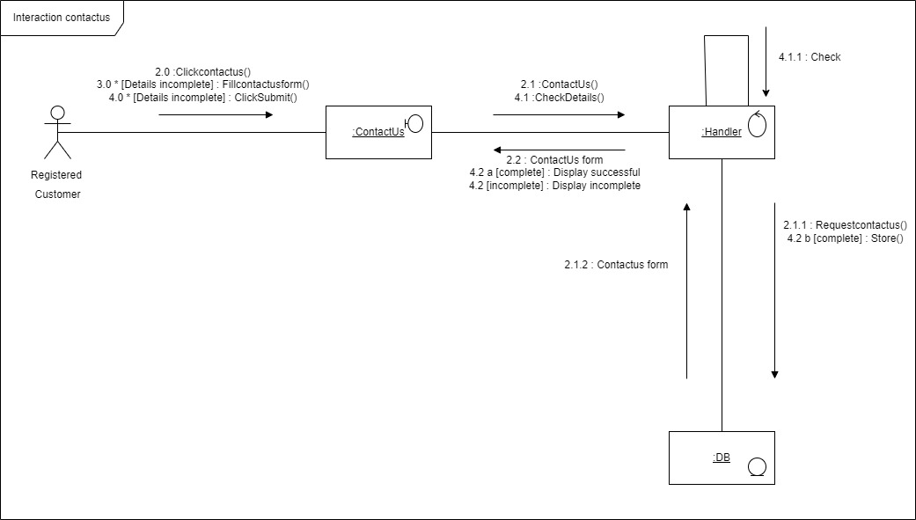

* I assume that the checking procedure is a part of the checkdetails().
* I assume that the fill contact form part and click submit part must repeatedly do until the user fills in the form details correctly.

**IT21176456 – Gimmana M.R.M**

* **Customer Buy Items online**

1. Usecase Scenario :

|  |  |  |
| --- | --- | --- |
| **Number** | B002 | |
| **Name** | Buy item(s) | |
| **Summary** | Customers buy items online | |
| **Priority** |  | |
| **Pre - Condition** | Customer view cart and select an item | |
| **Post-Condition** | Send purchased items to pack | |
| **Primary Actor** | customer | |
| **Main Scenario** | **Step** | **Action** |
|  | 1. | Customers select Item(s) |
| 2. | System checks availability of the selected item(s) |
| 3. | System Update the item cart |
| 4. | Display the cart to the customer |
| 5. | customer click purchase button to buy the item |
| 6. | system asks to give login credentials |
| 7. | Customer gives his login credentials |
| 8. | System checks the customer credentials |
| 9. | System displays payment page |
| 10. | Customer gives payment details |
| 11. | System checks payment details |
| 12. | System generates a bill |
| 13. | System displays the bill to customer |
| 14. | Customer place order |
| 15. | System updates store |
| 16. | System displays order success message |
| **Extensions** | **Step** | **Branching Actions** |
|  | 2a | If the items are not available system displays items is not in the stock |
| 2b | System asks customer to select item again |
|  | 6a | If login credentials are invalid, system asks to re-enter the login credentials |
|  | 8a | If login credentials are invalid, system ask to re-login |
|  | 11a | If payment details are invalid system ask to re-enter the details |

<https://drive.google.com/drive/folders/1xRjIfnHiXpsiIZbsLqgprxWVylWdnILN>

1. Sequence Diagram :

Customer login :

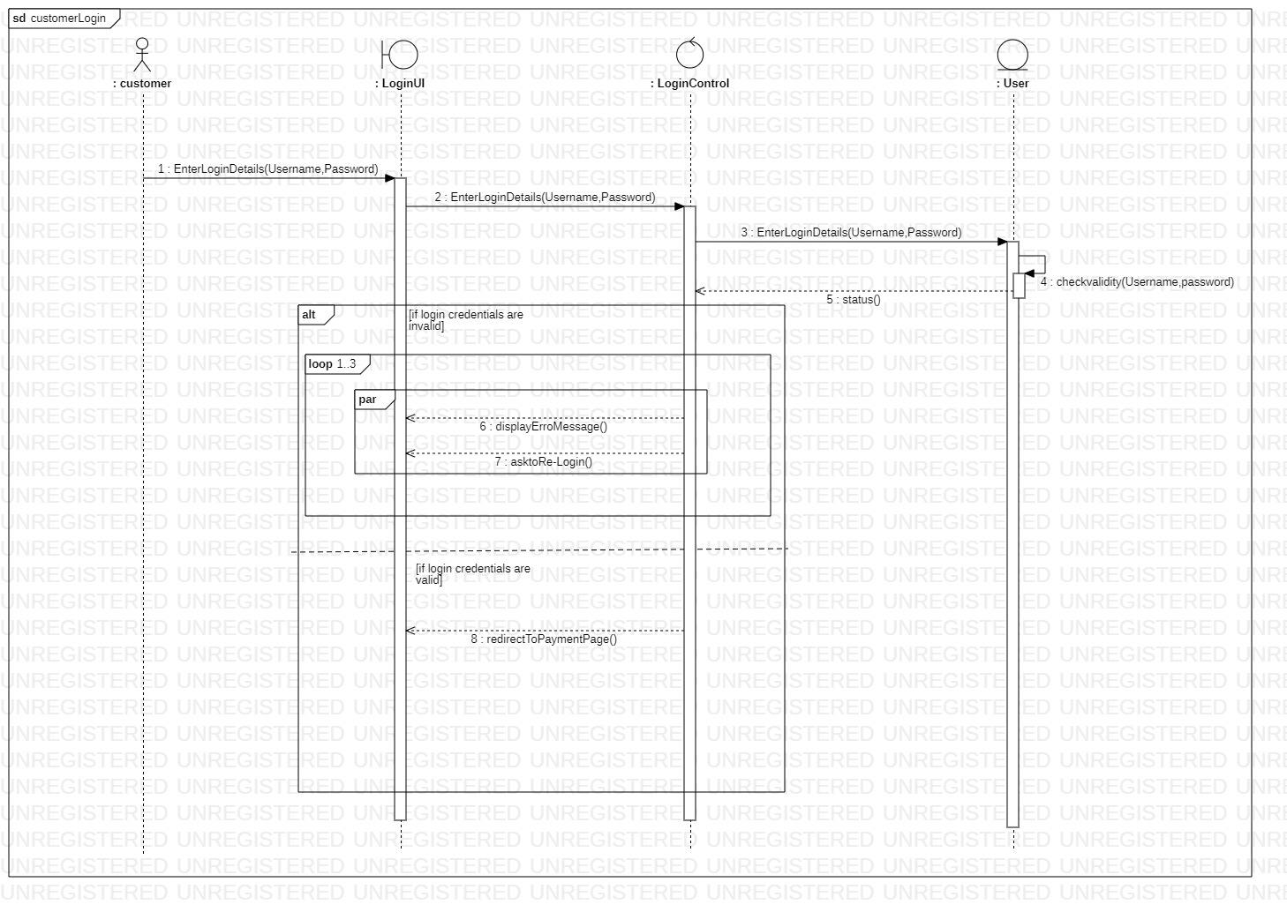

Buy Item Online :

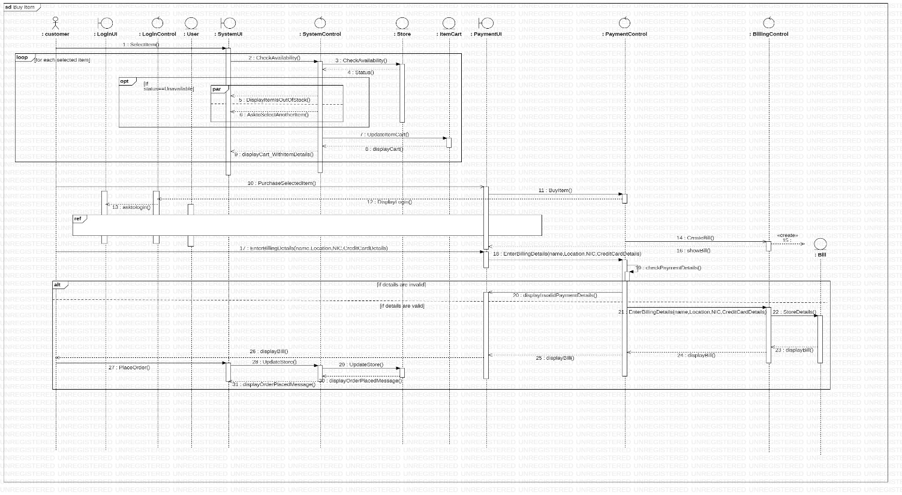

<https://drive.google.com/drive/folders/1xRjIfnHiXpsiIZbsLqgprxWVylWdnILN>

1. Communication Diagram

Login :

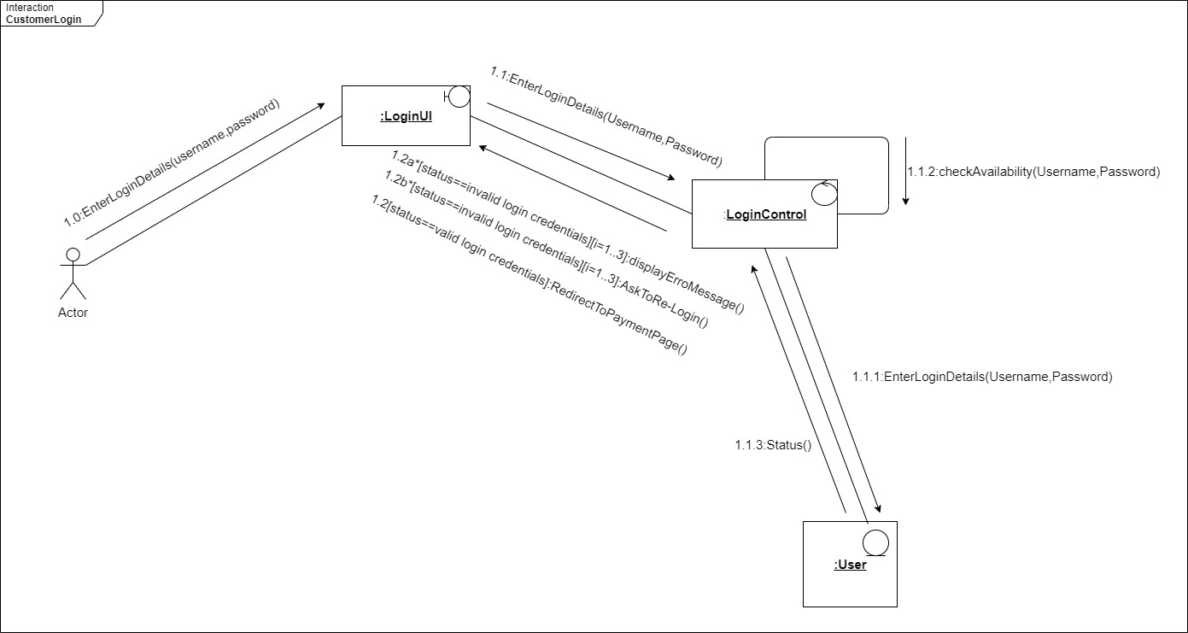

Buy Items :

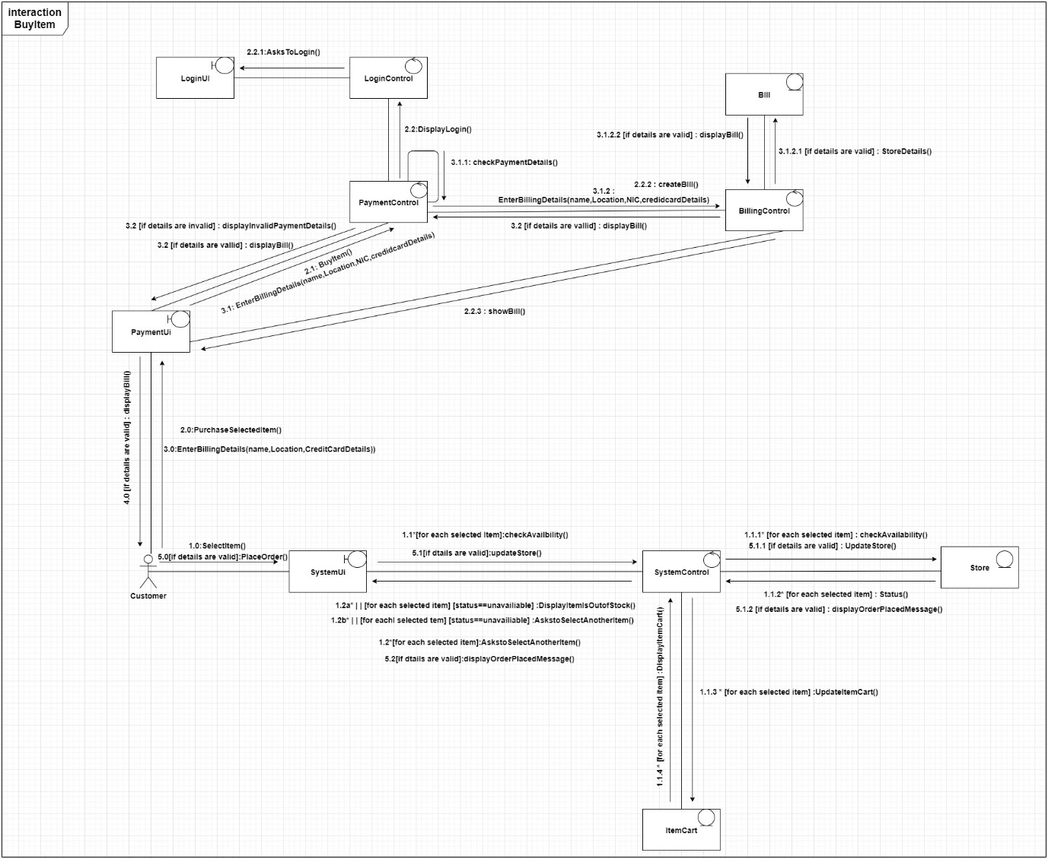

**IT21177996 – Cooray N.T.L**

1. Use Case Scenario

|  |  |  |
| --- | --- | --- |
| **Number** | 008 | |
| **Name** | Upload items and Description | |
| **Summary** | The moderator visits the System and has added items and Descriptions to the Website. | |
| **Priority** | 2 | |
| **Pre - Condition** | Moderator has a successfully registered account in this system and Moderator has already logged in to the website. | |
| **Post-Condition** | Moderator added an item with a description | |
| **Primary Actor** | Moderator | |
| **Main Scenario** | **Step** | **Action** |
|  | 1. | Moderator Logins to the Dashboard Using Username and Password or Google Authentication(Using Admin Approved Email) |
| 2. | The moderator goes through the website with he has features |
| 3. | Moderator clicks upload items button |
| 4. | Moderator access the upload items and Description panel |
| 5. | Select Items category moderator want |
| 6. | Give the particular name to upload video(s) or image(s) |
| 7. | Select the count moderator wants for the upload items |
| 8. | Upload items and update the database |
| 9. | Display ‘successfully uploaded items’ and display items they have added topic and description for the items |
| 10. | select an image or short video and then give the topic and Description of moderator uploaded things |
| **Extensions** | **Step** | **Branching Actions** |
|  | 1a | Provide the opportunity to log in again |
| 1b | If verification fails three times and display error an exist, the process |
|  | 6a | If items are already available in the system show images or short videos |
|  | 6.a.1 | then click the ok button |
|  | 6b | If a related item is not in their display “Not available message” |

1. Sequence Diagram

Login :

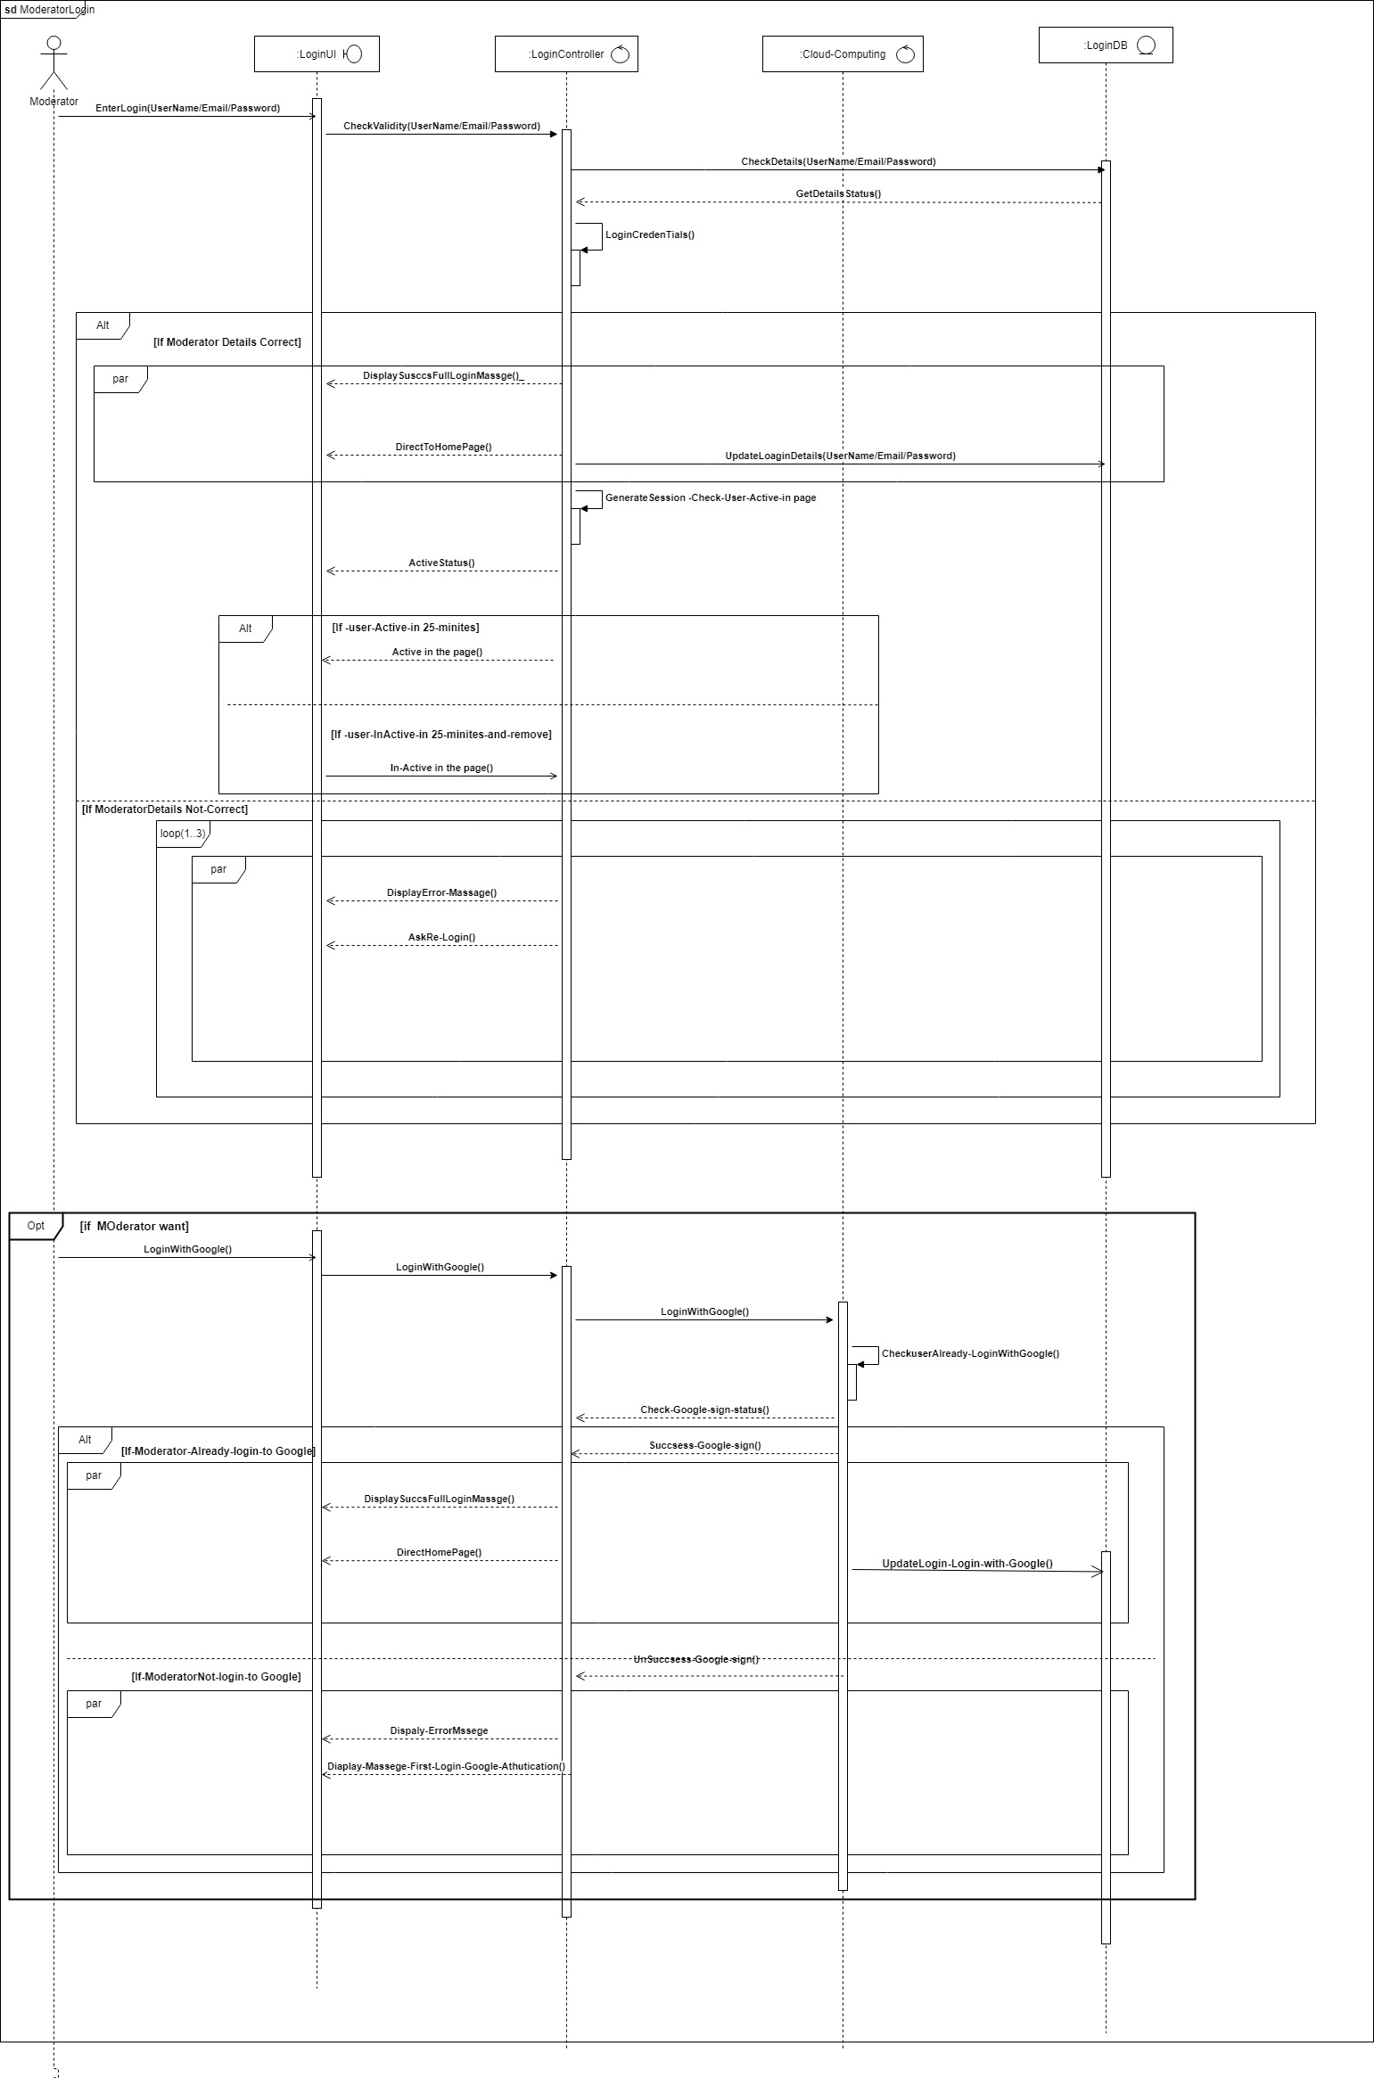



Item Upload and description :

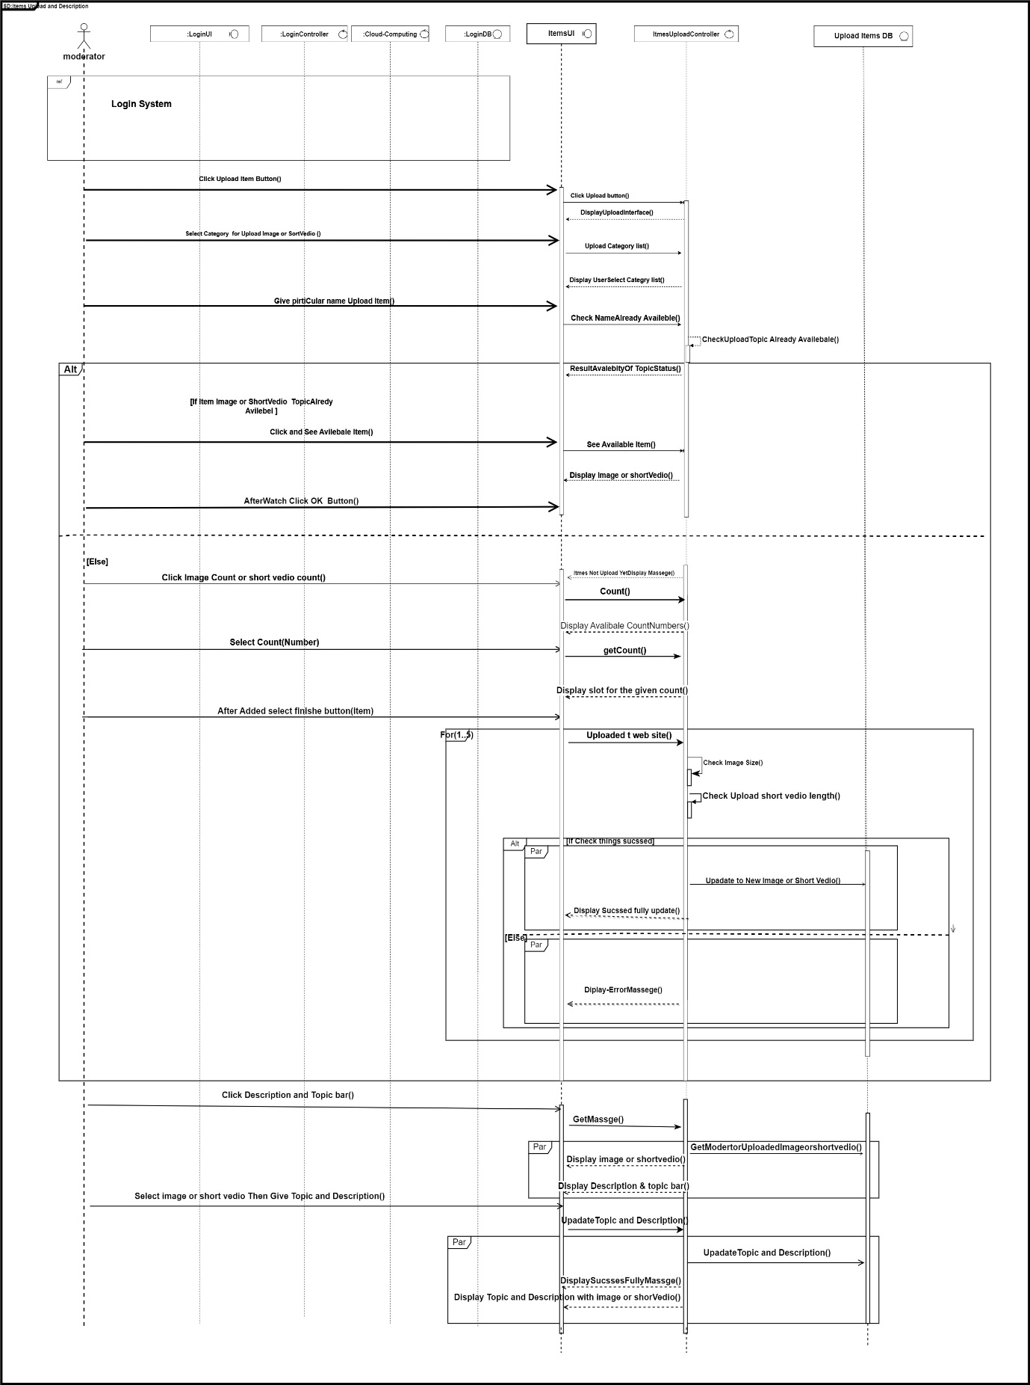

<https://drive.google.com/drive/folders/1xRjIfnHiXpsiIZbsLqgprxWVylWdnILN>

1. Communication Diagram

Login :

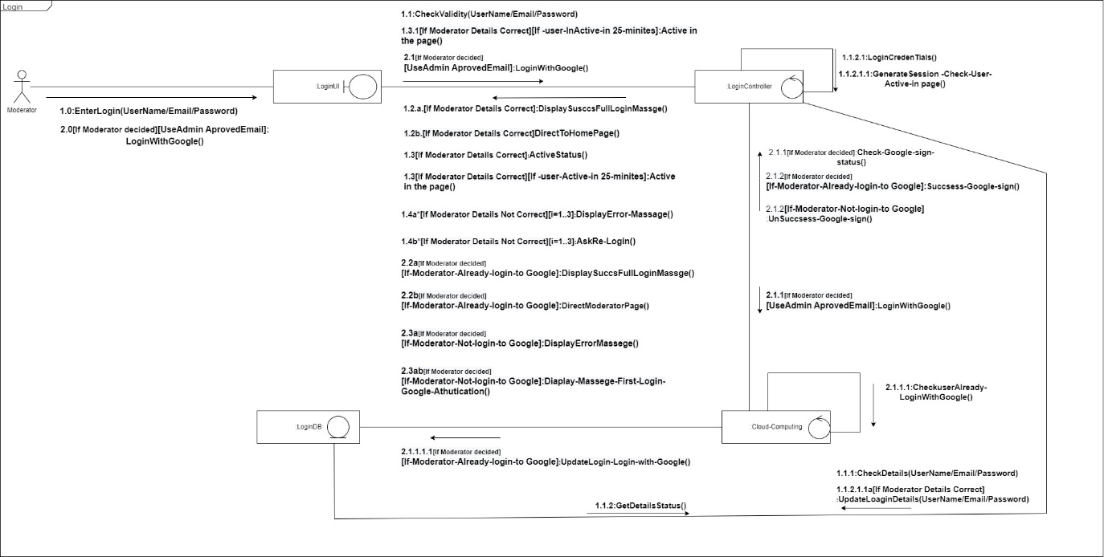

Item Upload and description :

**IT21174780 - D.M.M.I.T.Dissanayaka**

1 . Use case scenario :

|  |  |  |
| --- | --- | --- |
| **Number** | 008 | |
| **Name** | Customers browse an Item | |
| **Summary** | Customers browse and find item | |
| **Priority** |  | |
| **Pre - Condition** | Customer must visit the website | |
| **Post-Condition** | Customers find the item | |
| **Primary Actor** | Customer | |
| **Main Scenario** | **Step** | **Action** |
|  | 1. | Customers need to reach home page. |
| 2. | System checks all main category in the database and show all categories. |
| 3. | Customer needs to select what he wants to find from the category. |
| 4. | Display the price bar by including minimum and maximum price range by checking the database. |
| 5. | Customer select the price range from the price bar needed to be brows. |
| 6. | Show availability check bar. |
| 7. | Customer check in stoke Item. |
| 8. | Customer clicks Browsing Button |
| 9. | Preview item list using the conditions in database. |
| 10. | Customer can enter the item what he wants. |
| **Extensions** | **Step** | **Branching Actions** |
|  | 3a | Search Item using Search bar. |
| 5b | If does not select any price range, display all the price ranges item in the database. |
|  | 7a | If does not assign the availability, display all the item in the database. |
|  | 9a | If it is not in there in the item list, it shows suggestion items. |

1. Sequence Diagram

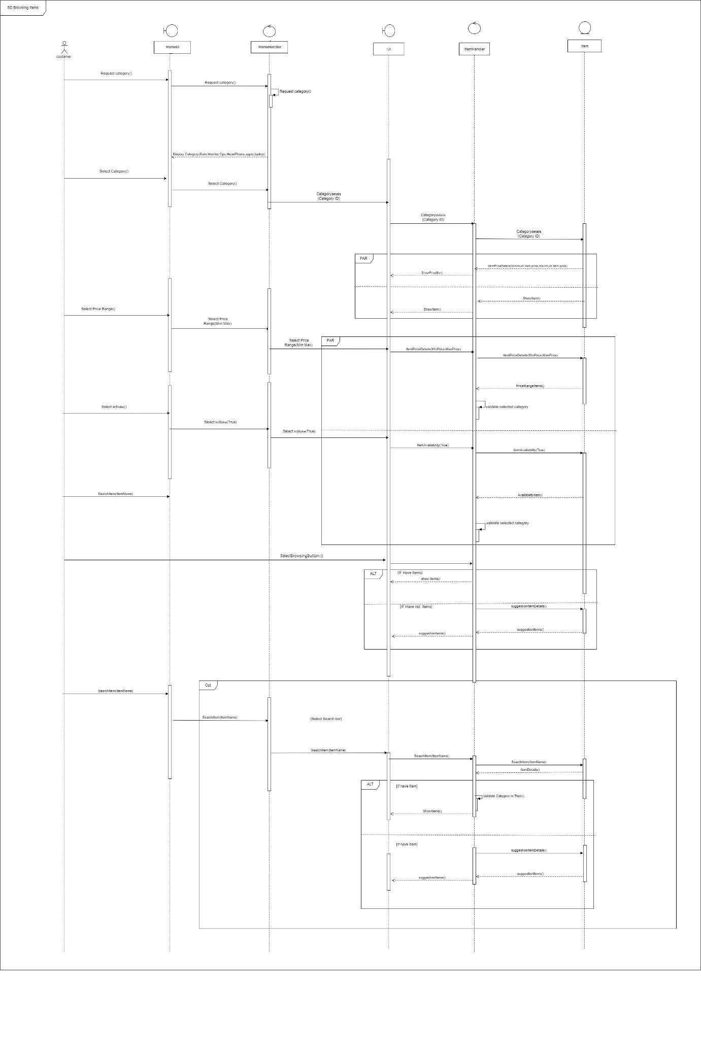

1. Communication Diagram :

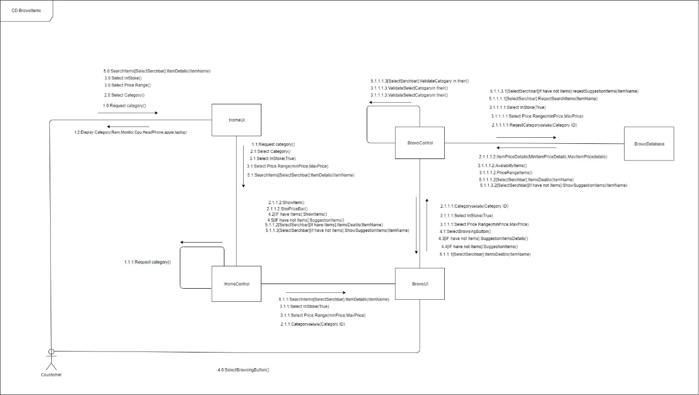

<https://drive.google.com/drive/folders/1xRjIfnHiXpsiIZbsLqgprxWVylWdnILN>

**Individual Contribution**

|  |  |  |
| --- | --- | --- |
| **Reg No** | **Name** | **Function Name** |
| IT21189944 | Madusanka G.K.I | 1. Customer Registration  * **Usecase scenario** * **Sequence diagram** * Loop * Break * Alt * Opt * par * C**ommunication diagram**  1. Contact website  * **Usecase scenario** * Loop * Alt * Ref * par * **Sequence diagram** * C**ommunication diagram** |
| IT21176456 | Gimmana M.R.M | 1. Buy Item  * **Usecase scenario** * **Sequence diagram** * Loop * Opt * Alt * Ref * Par * create * C**ommunication diagram** |
| IT21177996 | Cooray N.T.L | 1. Add item with description  * **Usecase scenario** * **Sequence diagram** * Loop * Alt * Par * Ref * C**ommunication diagram** |
| IT21174780 | D.M.M.I.T.Dissanayaka | 1. Browse an Item  * **Usecase scenario** * **Sequence diagram** * Alt * Opt * par * C**ommunication diagram** |